**User Manual**

1. Open the application “To do list”

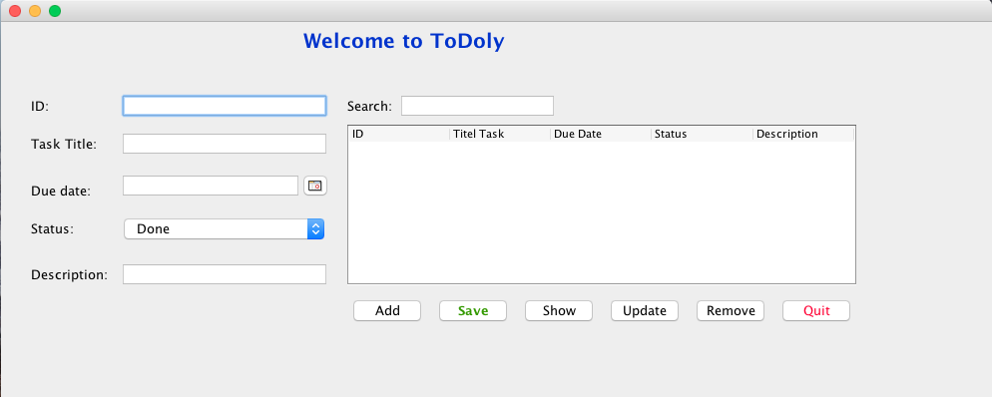

1. Fill in the fields as in the form, then click the Add button.

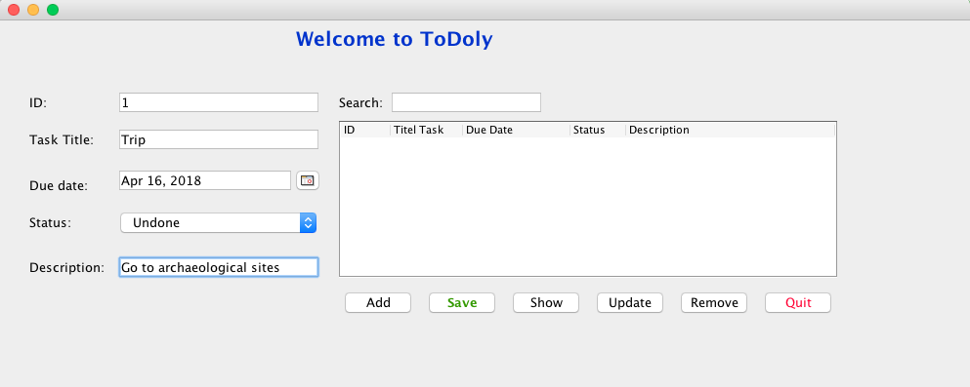

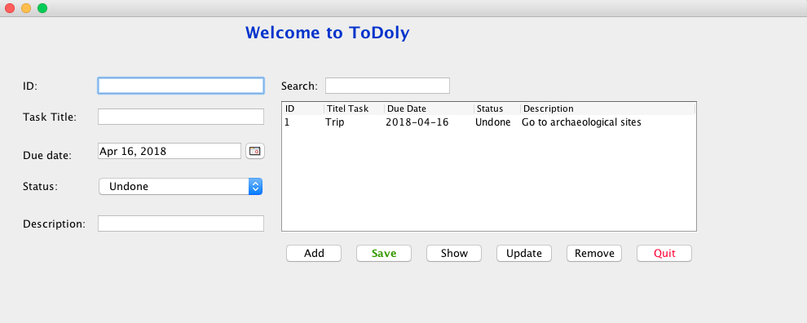

1. When you have finish to adding all tasks click the Save button.
2. **Show:** all tasks click the Show button.
3. **Edit**: Select the task you want to edit with the cursor as shown. Fill in the fields again, then click the Update button, Then click the Save button.

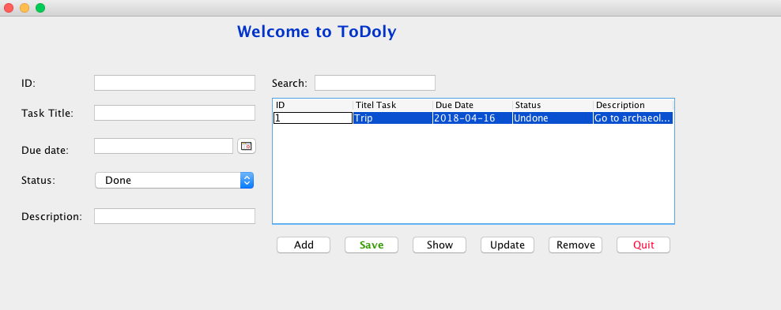

1. **Delete**: Select the task you want to delete it, then click the Remove button.
2. **Exit**: click Quit button.